Online Sales Information Web Portal
Design Document

Version 1.0



Group Id: F1602D8399
Supervisor Name: Faizan Tahir

Revision History
Date (dd/mm/yyyy) | Version | Description | Author
10/01/2017 | 1.0 | Design Document includes  1:- Introduction of design document  2:- Entity Relationship Diagram (ERD)  3:- Sequence Diagrams  4:- Architecture Design Diagram  5:- Class Diagram  6:- Database Design  7:- Interface Design  8:- Test Cases | Bc120400918

Table of Contents

- Introduction of Design Document
- Entity Relationship Diagram (ERD)
- Sequence Diagrams
- Architecture Design Diagram
- Class Diagram
- Database Design
- Interface Design
- Test Cases

- Introduction of Design Document
Design document is a document in which we have provided us complete information about our project design and also included all information you have asked in this document. Web portal provides a platform to know information about products on online. It shows online product offers. One of the biggest benefits of online shopping is that you can see any products online you could imagine without leaving your house. It also tends to provide more information about items for sale. There are numerous steps in the web site design and development process.

- Entity Relationship Diagram (ERD) (To be developed using Microsoft Visio or any other drawing software of your choice)
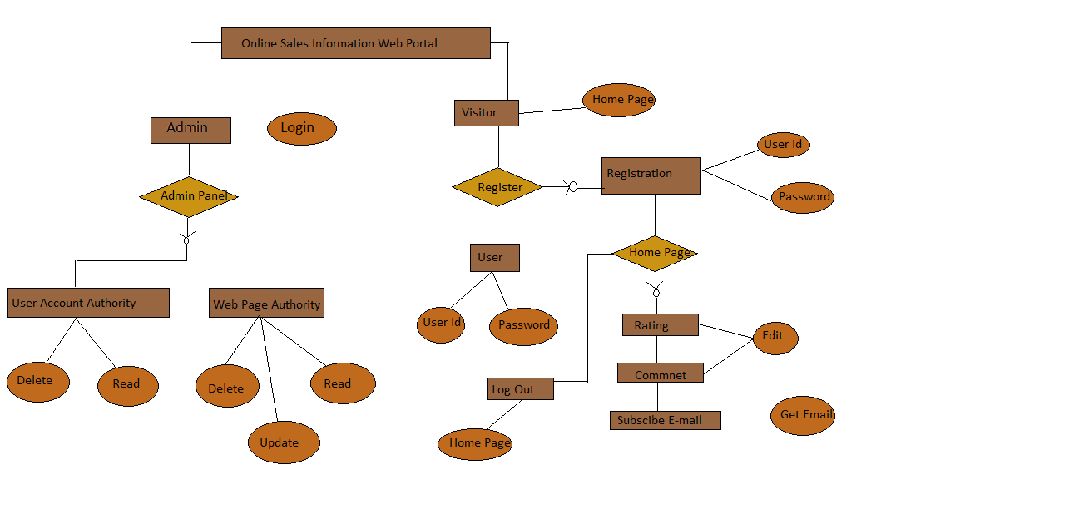

- Sequence Diagrams (To be developed using Rational Rose or any other drawing software of your choice)
1:- Registration
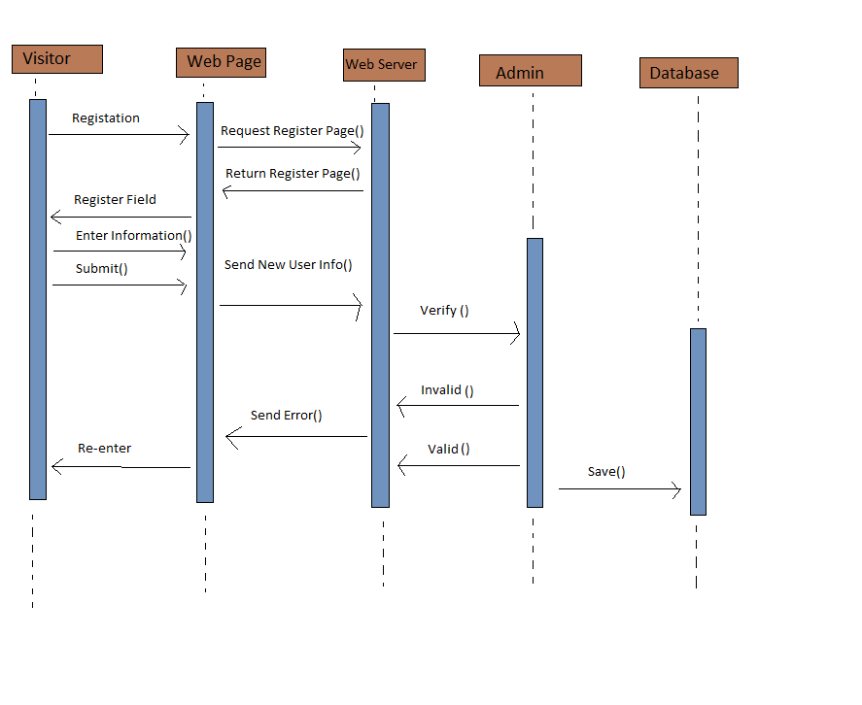

2:- User
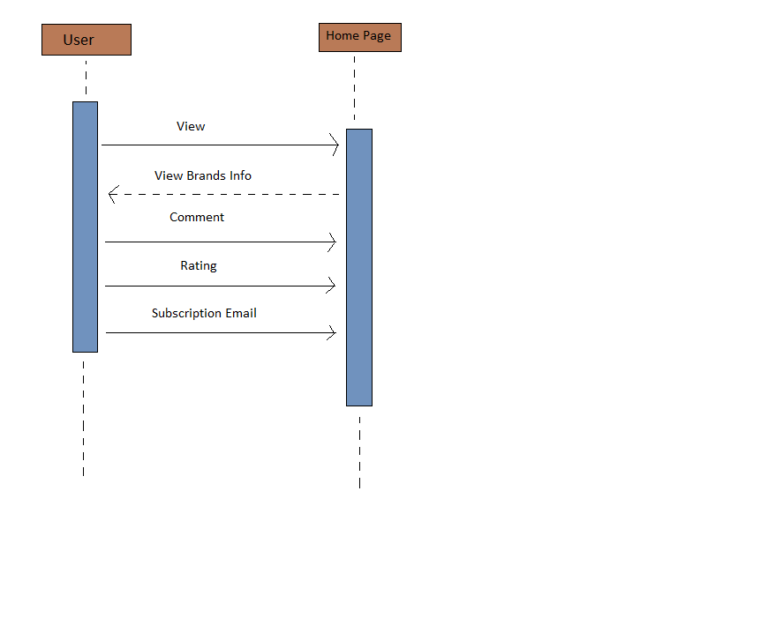

3:- Admin
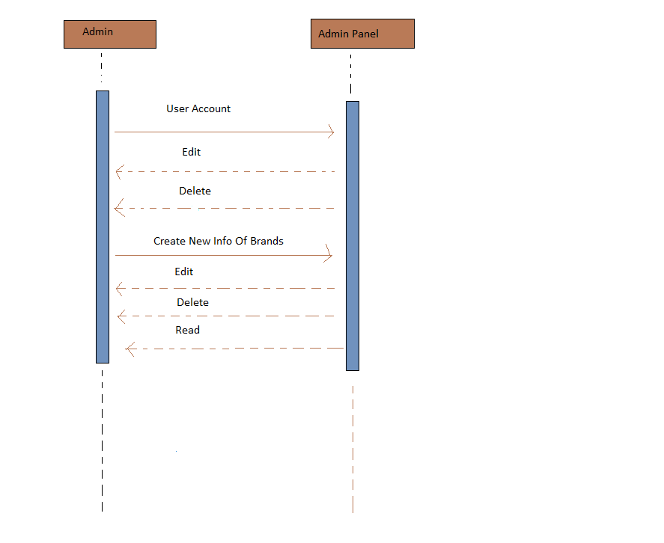

4:- Email
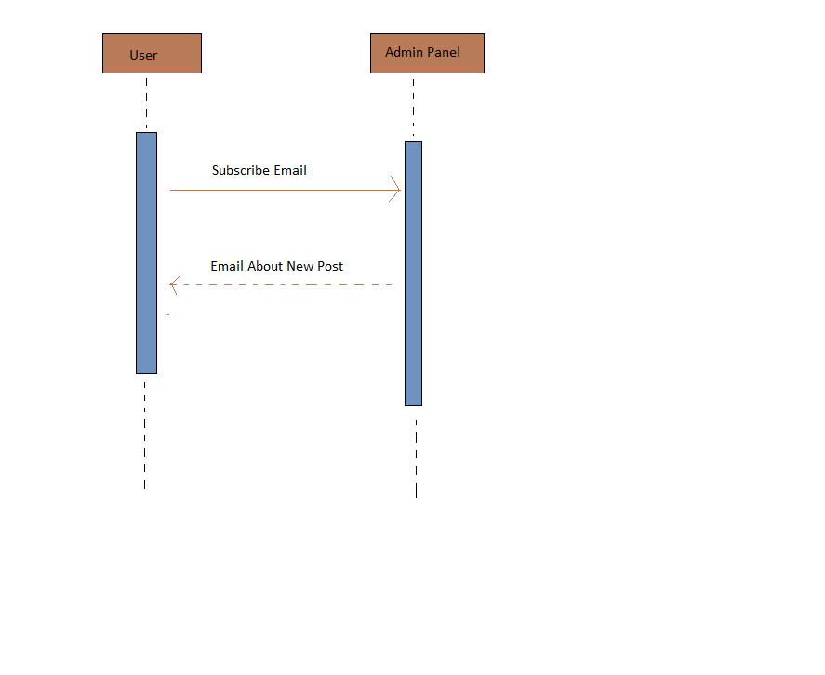

- Architecture Design Diagram
<Provide a Tiered Architecture of the system>

- Class Diagram

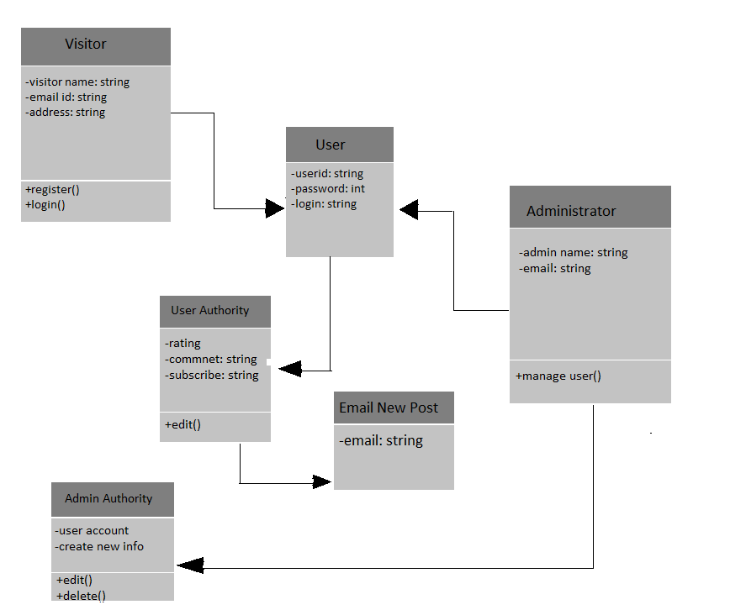

- Database Design

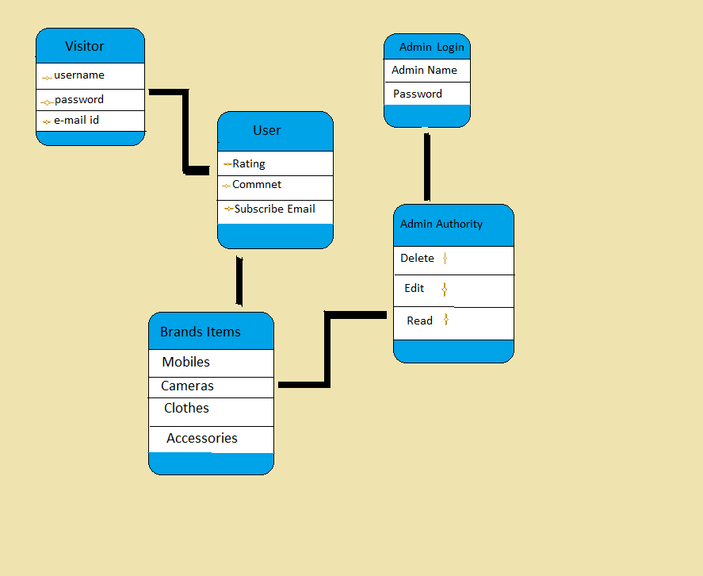

- Interface Design

<Provide here the screenshots (GUI) of the system (Provide 3 or 4 main GUIs/interfaces, to show the most important features of the application as you are visualizing your application to be, in actual development phase. You can update these GUIs in Final Report and Final Presentation, in case they are changed after the actual development.>

- Test Cases

Test case # 1:-

Test Case Title: Admin
Preconditions | All must require information about visitors.
Actions | Admin will create new info about brands or edit or delete and have authority of user accounts.
Expected Results | Admin authority succeeds.
Tested By: | Mohsin
Result | Pass/Fail

Test case # 2:-

Test Case Title: Registration in our website.

Preconditions | All must require information about the new user should be available.
Actions | User will able to login in our website.
Expected Results | Website should provide user name and password to login.
Tested By: | Mohsin
Result | Pass/Fail

Test case # 3:-

Test Case Title: Visitor
Preconditions | 1:- All must require latest information about brands should be available.  2:- In this case visitor must browse and register web portal.
Actions | Visitor will browse website and can subscribe and can ratings and comments. After subscribe also got e-mail about latest info of brands.
Expected Results | Visitor requirements fulfill
Tested By: | Mohsin
Result | Pass/Fail

